# CS3910: Assignment 3: Installing Windows and Critical Services

# Mordred Cameron

# University of Colorado Colorado Springs

In partial fulfillment of the requirements for CS3910

Instructor: Rhett Saunders

3/1/2024

# Introduction to Installing Windows and Critical Services

In this assignment, the outcome provided insight into installing an active directory onto Windows 2019/2022, creating 3 users, and logging into each respective user via an RDP session.

Assignment Results

Based on these screenshots, this is what I learned.

Installing Active Directory:

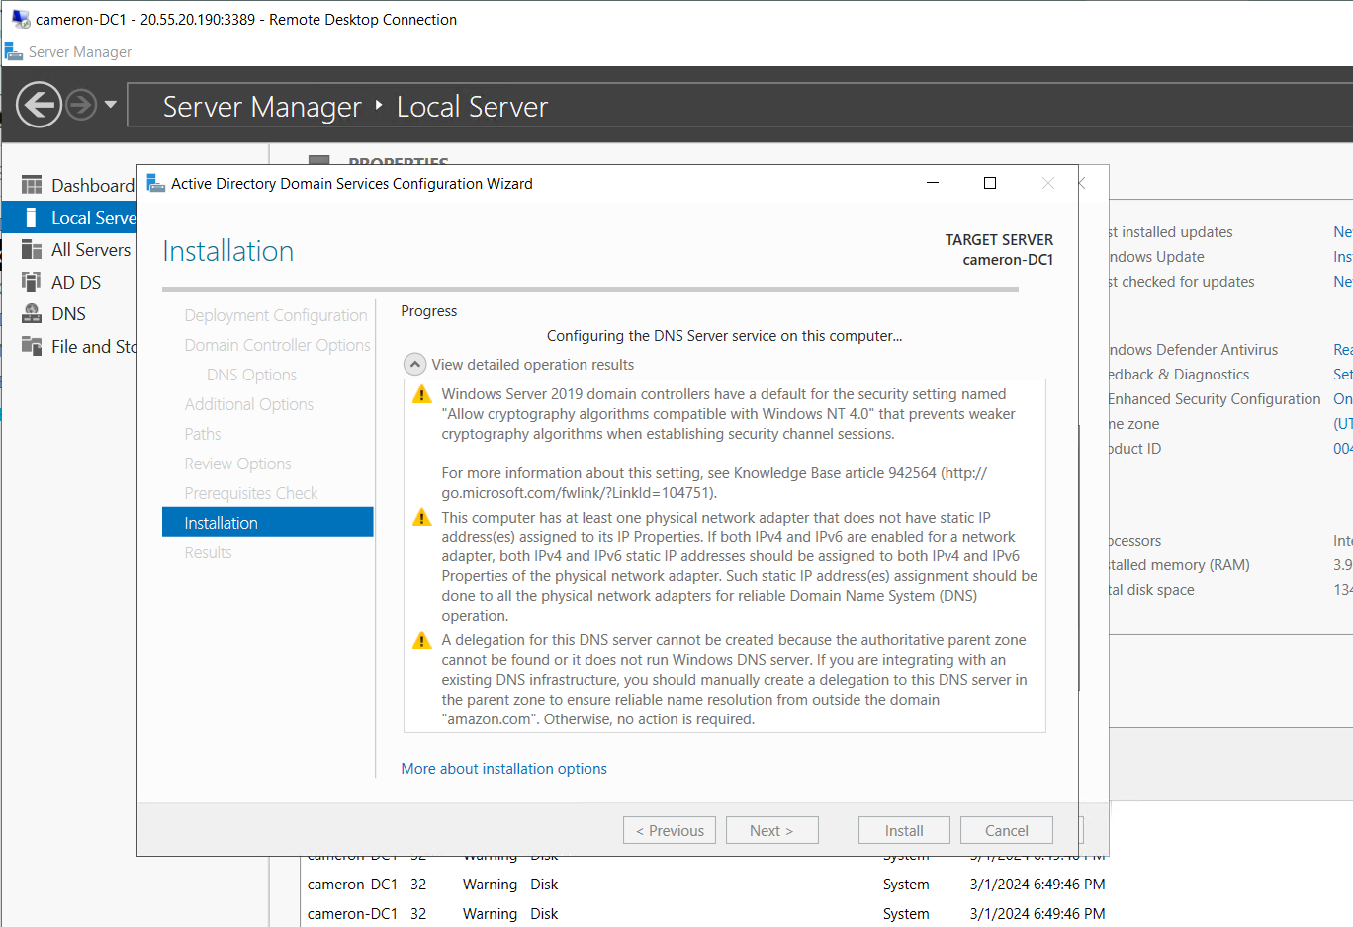

Creating Users:

Logging Into New Users:

Conclusion

In summary, by following along with the walkthrough in class and using the step by step guide, I learned how to install an active directory, add users, change the groups that the users belong to as well as their remote login abilities, and logging into different users with the same RDP session.

References

*Cloud computing services: Microsoft Azure*. Cloud Computing Services | Microsoft Azure. (n.d.). https://azure.microsoft.com/en-us

Rakholiya, M. (2023, May 6). *How to setup active directory on windows server 2019*. MSFT WebCast. https://msftwebcast.com/2019/03/step-by-step-guide-how-to-setup-active.html